**WEB PROGRAMING LANGUAGES WEEKLY ACTIVITY 06**

**1.example 1, calculator example**

Here is the screen shots:

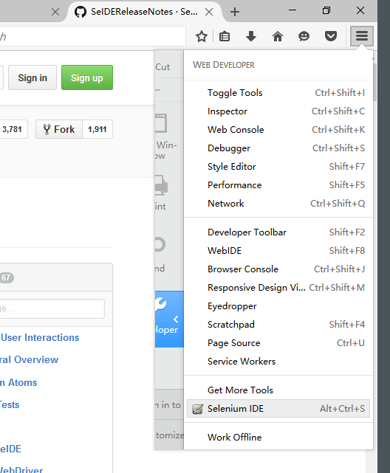

Somehow my selenium IDE for firefox is not shown in the tool bar after installation, but I found it in the WEN DEVELOPER menu.

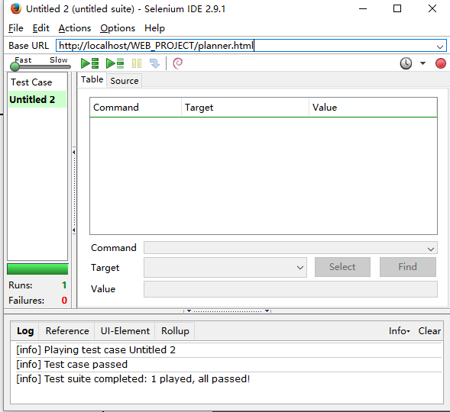

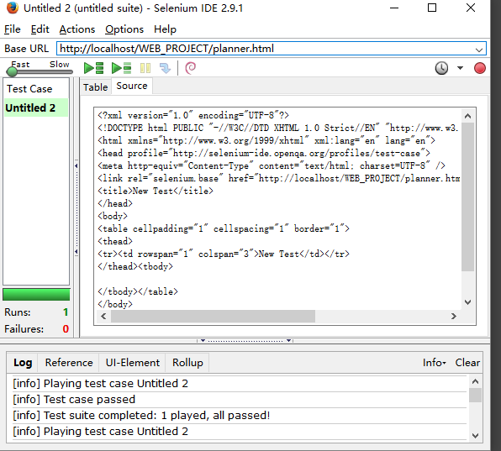

|  |
| --- |
| **Table of Contents** |
| **Screen shots for selenium test cases** |